**Premiere**

Mary Katelyn P. Elen

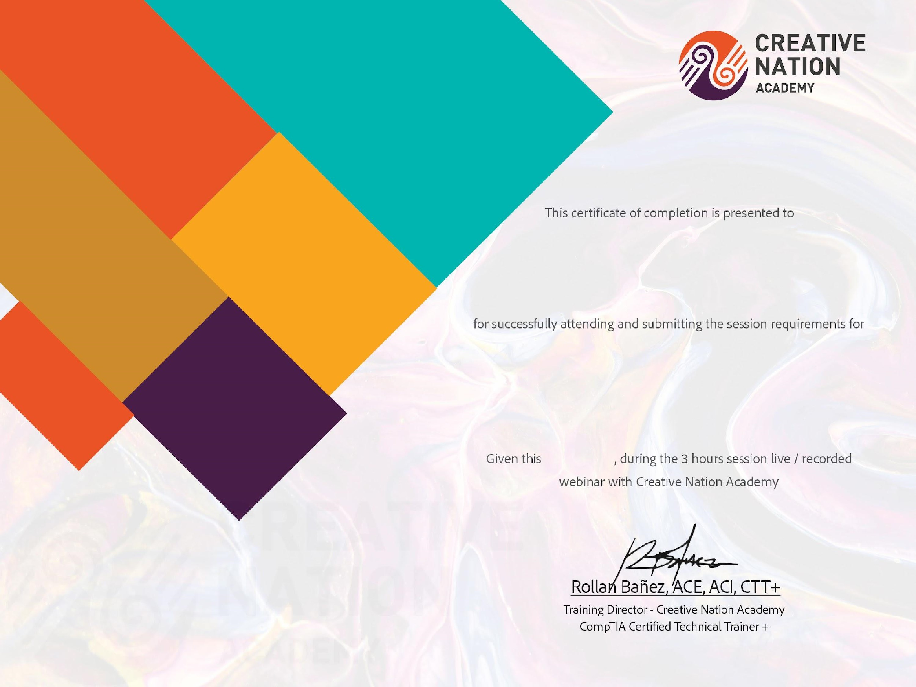

**Learning Adobe**

**Zero to Hero**

**Using Adobe**

**/**

**9 / 06 / 2023**

**Learning Adobe Captivate 2023**

**for Educators**